**EDUFLEX: ADAPTIVE ONLINE LEARNING SYSTEM TO ENHANCE PRIMARY EDUCATION**

Samarakkody G.K.G.D.A

IT20619558

BSc (Hons) in Information Technology Specializing in Data Science

Department of Information Technology

Sri Lanka Institute of Information Technology

Sri Lanka

April 2024

**EDUFLEX: ADAPTIVE ONLINE LEARNING SYSTEM TO ENHANCE PRIMARY EDUCATION**

Samarakkody G.K.G.D.A

IT20619558

Dissertation submitted in partial fulfillment of the requirements for the Bachelor of Science (Hons) in Information Technology Specializing in Data Science

Department of Information Technology

Sri Lanka Institute of Information Technology

Sri Lanka

April 2024

# DECLARATION

I declare that this is my own work and this dissertation1 does not incorporate without acknowledgement any material previously submitted for a Degree or Diploma in any other University or institute of higher learning and to the best of my knowledge and belief it does not contain any material previously published or written by another person except where the acknowledgement is made in the text.

Also, I hereby grant to Sri Lanka Institute of Information Technology, the non-exclusive right to reproduce and distribute my dissertation, in whole or in part in print, electronic or other medium. I retain the right to use this content in whole or part in future works (such as articles or books).

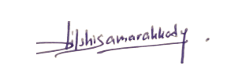

Signature: Date: 04/04/2024

The above candidate has carried out research for the bachelor’s degree Dissertation under my supervision.

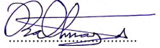

Signature of the supervisor: Date: 04/04/2024

(Mr. Samadhi Rathnayake)

# ABSTRACT

The rise of online learning platforms, particularly in elementary education, has led to a need to address the challenges of maintaining student involvement and attention in virtual classrooms. The lack of physical connection often results in shorter attention spans, making it difficult for educators to measure their engagement. This study aims to propose a unique way to monitor students' attentiveness in real-time during online quizzes using Deep learning Techniques. The research aims to establish a framework for monitoring student attention levels using machine learning within an adaptive online learning environment. Transfer learning methods, leveraging a pertained MobileNet model, are used to construct a machine learning model capable of determining whether a student is paying attention and not paying attention during online quizzes. A dataset including children's facial expressions and attention labels is applied for model training. Face detection algorithms are used to continuously monitor students' facial expressions throughout assessments, providing immediate feedback on their concentration levels. At the end of the quiz, the attention score will be displayed. The study's results have significant implications for Artificial Intelligence in education. By efficiently monitoring student attention in real-time, Teachers can better identify and address individual learning requirements, resulting in a more engaging and productive online learning environment. This technique opens doors for further research in customized learning methods and adaptable educational technology, enhancing distant learning experiences.

Keywords: Transfer Learning, Deep Learning, Machine Learning, Face Detection Algorithms.

# ACKNOWLEDGMENT

I am immensely thankful for the continuous guidance and support provided by my dissertation supervisor, Mr. Samadhi Rathnayake, and co-supervisor, Dr. Darshana Kasthurirathna, affiliated with the Faculty of Computing.

I express deep gratitude towards the committed faculty members of the Faculty of Computing for their unwavering assistance and encouragement during my academic voyage. Their dedication to both educational instruction and scholarly research has served as a genuine wellspring of motivation. Additionally, my appreciation extends to Dr. Jayantha Amararachchi, who oversaw the project, and the CDAP team for their support in ensuring the project's accomplishments.

Furthermore, I want to convey my thanks to my team members for their invaluable backing and collaborative endeavors. The enlightening dialogues and exchange of ideas among us have notably enhanced my understanding of the subject matter.

Particular appreciation is due to Mrs. K.L.A.Priyalatha, Deputy Principal at Kottawa North Darmapala Vidyalaya, for her generous assistance in the data collection process for my research. Her contributions have played a pivotal role in the successful realization of this project.

Finally, I would like to express my appreciation to all those who participated in this study and contributed their time and insights. Their willingness to share their experiences and perspectives has been invaluable in helping me to gain a deeper understanding of the subject matter.

# TABLE OF CONTENT

DECLARATION 3

ABSTRACT 4

ACKNOWLEDGMENT 5

TABLE OF CONTENT 6

LIST OF FIGURES 8

1. INTRODUCTION 10

1.1 Literature Review 10

1.2 Research Gap 12

1.3 Research Problem 14

1.4 Research Objectives 15

1.4.1 Main Objective 15

1.4.2 Sub-Objectives 16

2. METHODOLOGY 19

2.1 Methodology 19

2.1.1 Requirement Gathering 19

2.1.2. Dataset Description 19

2.1.3. System Architecture 20

2.1.4 Component Architecture 21

2.1.5 Tools and Libraries 22

2.1.6 Model Architecture and Model Implementation 22

2.1.7 Face Detection Using MTCNN 29

2.1.8 Face Extraction 32

2.2. Commercialization Aspects of the Product 33

2.2.1. Target Market 33

2.2.2. Revenue Streams 34

2.2.3. Marketing Approach 34

2.3 Testing and Implementation 35

2.3.1. Functional Requirements 35

2.3.2. Non-Functional Requirements 36

2.3.3 Backend Implementation 37

2.3.4. Frontend and Backend Testing 39

3. RESULTS AND DISCUSSIONS 42

3.1 Results. 42

3.2 Research Findings. 45

3.3 Discussion 46

3.3.3 Limitations and Future Directions 47

4. CONCLUSION 49

5. REFERENCES 51

# LIST OF FIGURES

Figure 1:Sample data 19

Figure 2:Overall system diagram 19

Figure 3:Overall Component Diagram 20

Figure 4:Import Libraries for model implementation 21

Figure 5: Load the dataset and Preprocessing. 22

Figure 6: Model defining image 1 22

Figure 7: Model defining image 2 22

Figure 8: Reshape and add output layer 23

Figure 9:: Freeze the weights. 23

Figure 10:: Compile the model. 23

Figure 11:Early stopping callback function. 24

Figure 12:: Fit the model. 24

Figure 13:Terminate the model training. 24

Figure 14: layers in base model 25

Figure 15: Start model fine-tuning. 25

Figure 16: View model summary 25

Figure 17: Training the fine-tuned model. 26

Figure 18: Evaluate model for test batches. 26

Figure 19: loading test images 1 26

Figure 20: Loading test images 2 27

Figure 21: Predict test images. 27

Figure 22: Confusion Matrix for model 27

Figure 23: Import libraries for face detection model 28

Figure 24: load images 28

Figure 25: function define and input images. 29

Figure 26: facial key points of image 29

Figure 27: Detecting Face 30

Figure 28: library import for face extraction. 31

Figure 29: Define function for face extraction. 31

Figure 30: Extract and load images. 32

Figure 31 Import libraries for backend 36

Figure 32:Define function for class prediction. 36

Figure 33: Real – time predictions taking. 37

Figure 34: Home page 38

Figure 35: Student attention giving. 38

Figure 36: Student attention not giving. 39

Figure 37:Pop-up message 39

Figure 38: Results of the quiz 40

Figure 39: Results dashboard 40

Figure 40: Before fine - tuning the model. 41

Figure 41: Before fine - tuning the model accuracy. 42

Figure 42: After fine-tuning the model matrix 42

Figure 43: Model after fine-tuning accuracy. 43

Figure 44: Confusion matrix for the model 43

# 1. INTRODUCTION

## 1.1 Literature Review

Attention-aware systems are used to track learners' attention in e-learning settings. These systems strive to provide an excellent e-learning experience by monitoring students' attention levels in real time. Attention levels are estimated and tracked using a variety of approaches and algorithms, including face analysis and head posture characteristics. The suggested solutions may offer feedback to both students and instructors, therefore improving the learning process. The attention tracking systems are intended to be real-time, inexpensive, and conveniently accessible via web applications.

Attention aware system have been suggested in academic research to enhance the connection between traditional classroom settings and online learning environments. These systems utilize techniques such as face detection, corner detection, eye detection, corner detection [1]to track the attention. E-learning platforms collect video footages of student faces and analyze their learning attention through eye gaze detection, facial expression detection head pose detection. There is a limited research on monitoring attention in offline settings where the camera in positioned at a distance, capturing small and less defined facial features [2]The students attention monitoring and Alert Model (S-AMAM) is an algorithm proposed for monitoring the attention of the students during the online classes by utilizing face detection and facial landmark detection techniques. Which determines students’ attention state such as ‘Normal’, ‘Dowsing’, ‘Yawning’. The algorithm generates real-time alerts for dowsing and yawning students [3]  
  
Implementing student attention monitoring system is crucial in e-learning platforms for young learners to enhance the effectiveness of e-learning by real-time attention tracking [4]. Research has shown student attention monitoring systems and alert systems for online classes utilize facial recognition and expression analysis to monitor student attentiveness, with the goal of combating decreasing focus level among students [3]Researchers used real-time web camera and estimate students attention levels using videos or images [3] [4] [5]Most of the studies combine physical and emotional facial features for attentiveness detection by utilizing image processing techniques and machine learning algorithms [4] [5] [3]Studies have employed both verbal and non-verbal measures to evaluate attention levels [4] [5]Some research has utilized non-verbal cues to determine the state of attentiveness [3]

Studies aim to improve online e-learning teaching techniques by identifying learner attentiveness using web cam information [3] [5] [4]The approach uses a machine learning model based on physical and emotional measurements, but the training data set is limited [4] [3]Further research need to enhance the performance of attention monitoring systems despite the lack of training data. The methodology of the study aims to address the existing gaps through its focus on enhancing the functionality of attention monitoring systems, even in the presence of limited training data. Transfer learning, a technique in deep learning, leverages a pre-trained model from a vast dataset to commence a new task, such as the classification of images [6]Through this approach, image classification is enhanced by the transfer of knowledge, leading to improved performance and the ability of models to adapt to diverse domains or datasets [6]Furthermore, transfer learning reduces the training time and enhances computational efficiency, thus making it widely employed in image classification tasks [6]

## 1.2 Research Gap

Several studies have explored the application of machine learning and computer vision techniques for monitoring student attention during online classes, there is a lack of research specifically addressing the unique challenges of assessing attention levels during online quizzes and assessments, particularly in elementary education settings. Existing approaches often rely on standard computer vision algorithms or shallow machine learning models, which may not be sufficiently accurate or resilient for the dynamic and diverse facial expressions produced by children during assessments. Systems are created for broad online learning scenarios, failing to account for the special context and requirements of online quizzes and evaluations. One of the biggest disadvantages of current attention monitoring systems is their inability to efficiently handle occlusions, varied lighting conditions, and different viewing angles, which are regular occurrences during online exams. Children may turn their heads, obstruct their faces with their hands, or have different lighting conditions in their home situations, resulting to potential mistakes or failures in attention detection. Existing methods focus exclusively on physical indications, such as head pose or eye gazing, overlooking the relevance of emotional and contextual aspects that can dramatically influence a child's attention level. The lack of a holistic method that incorporates physical, emotional, and environmental clues may result in an insufficient assessment of a student's attentiveness during online tests. Another key drawback is the lack of real-time feedback and adaptability in current attention monitoring systems. Most present systems provide delayed or post-hoc analysis, which restricts their effectiveness in supporting immediate interventions or revisions during online examinations.

Educators need real-time information on students' attention levels to dynamically alter their teaching tactics, provide timely support, or modify the assessment format to retain engagement. The majority of attention monitoring research has focused on adult learners or higher education settings, forgetting the specific problems and developmental characteristics of elementary school children. Children's attention spans, facial expressions, and behavior patterns during examinations may differ greatly from those of older pupils or adults, necessitating procedures customized to their age group and educational context. suggested study tackles these research gaps by leveraging deep learning techniques and transfer learning methods to construct a robust and accurate attention monitoring system specifically built for online quizzes and evaluations in elementary education. By leveraging a pre-trained MobileNet model and fine-tuning it on a dataset of children's facial expressions and attention labels, your solution tries to overcome the constraints of classic computer vision approaches and shallow machine learning models. This research incorporates face detection algorithms to continuously monitor students' facial expressions throughout tests, delivering real-time feedback on their attentiveness levels. This real-time monitoring tool addresses the requirement for fast interventions and changes during online tests, enabling educators to respond promptly to swings in student attentiveness.

|  |  |  |  |  |
| --- | --- | --- | --- | --- |
| Research Gap | Research A [5] | Research B  [2] | Research C  [1] | Proposed Solution |
| Focused on online quizzes / assessments in elementary education | No | No | No | Yes |
| Utilize deep learning techniques for attention monitoring | Yes | No | Yes | Yes |
| Employs transfer learning with pre-trained model | No | No | No | Yes |
| Real – time attention monitoring during assessments | No | No | No | Yes |
| Tailored dataset of children’s facial expressions and attention labels | No | No | No | Yes |
| Combine physical, emotional, and contextual cues. | No | No | Yes | Yes |
| Address overfitting and robustness challenges. | No | No | No | Yes |

*Table 1: Research Gap*

In summary, the research could significantly advance the application of artificial intelligence in educational contexts by addressing the challenges of tracking student engagement during online assessments and quizzes, particularly in elementary school environments. By establishing a strong, real-time, and context-aware attention monitoring system, your study can pave the way for more engaging and productive online learning experiences, thereby boosting the educational results of young learners in virtual classroom environments.

## 1.3 Research Problem

In online learning, particularly for elementary school students, sustaining constant engagement and attentiveness during virtual tests and quizzes offers a considerable problem. The absence of a physical classroom setting and the lack of direct connection between professors and students can contribute to shorter attention spans and disengagement, thus hurting the learning process. Traditional methods of judging student attentiveness, which mainly rely on visual signals and in-person observation, become useless in the setting of online learning platforms. The challenge in effectively tracking attention levels during online quizzes and exams derives from the limitations of existing attention monitoring technologies. Many of these systems apply shallow machine learning models or classic computer vision techniques that may not be sufficiently robust or accurate in capturing the nuanced facial expressions and behaviors demonstrated by students in a virtual learning environment. These methods typically fail to account for the broad variety of environmental circumstances, such as varying lighting conditions, occlusions, or viewing angles, that can exist in a student's home setting during online assessments. Some existing attention monitoring solutions are developed for generic online learning scenarios, neglecting the special context and requirements of online quizzes and assessments. These systems frequently give delayed or post-hoc analysis, limiting their effectiveness in supporting prompt adjustments or adaptations during the evaluation process. Educators demand real-time information on students' attention levels to dynamically adapt their teaching tactics, provide timely support, or modify the assessment format to retain engagement. Combining physical clues, such as facial expressions and eye gaze, with emotional and environmental aspects that can dramatically influence a child's attention level during online examinations. The lack of a comprehensive and holistic strategy that integrates these varied aspects may result in an insufficient understanding of a student's attentiveness, leading to erroneous assessments and unsatisfactory learning outcomes.

To solve these problems, there is a pressing need for a comprehensive and accurate attention monitoring system specifically built for online quizzes and assessments in elementary education settings. By applying transfer learning methods, the system can be efficiently trained on a dataset of children's facial expressions and attention labels, capturing the specific characteristics and behaviors of this age group. The suggested attention monitoring system should feature real-time monitoring capabilities, enabling continuous tracking of students' facial expressions and concentration levels throughout online assessments. This real-time input will equip instructors to swiftly recognize and resolve swings in student involvement, facilitating immediate interventions or adaptations to maintain a productive and engaging learning environment. This proposed system should harness the capabilities of deep learning techniques, transfer learning methods, and a specialized dataset of children's facial expressions and attention labels to overcome the limitations of existing approaches.

## 1.4 Research Objectives

### 1.4.1 Main Objective

The overarching objective of this research is to develop a robust and accurate attention monitoring system for online exams and assessments in elementary education settings. This attention monitoring system employs transfer learning, a deep learning technique, to monitor students' attention levels during virtual assessments and provide real-time feedback on their engagement. The system will utilize a tailored dataset of children's facial expressions and attention labels, combined with a comprehensive approach that integrates physical, emotional, and contextual indicators. This holistic approach will enable educators to promptly identify and resolve fluctuations in student attentiveness, facilitating immediate interventions and tailored educational strategies to enhance the online learning experience.

### 1.4.2 Sub-Objectives

Sub-Objective 1: Collecting the dataset and annotating the dataset.

* Specific: Collect the dataset and extract the facial expressions of the children images using MTCNN machine learning model and annotate the dataset.
* Measurable: Dataset comprises images of 350 elementary students and annotate corresponding attention labels before the first progress presentation.
* Achievable: Leverage existing datasets and collaborate with elementary schools to acquire the required data.
* Relevant: A tailored dataset is crucial for training the attention monitoring system to accurately capture the unique characteristics of children's facial expressions and behaviors during online assessments.
* Time-bound: Complete the dataset curation and annotation process within the first three months of the research endeavor.

Sub-Objective 2: Implement Transfer Learning with Pre-trained Models for Attention Monitoring

* Specific: Employ transfer learning techniques by leveraging pre-trained deep learning models, such as MobileNet, to develop an efficient and accurate attention monitoring system.
* Measurable: Achieve an attention monitoring accuracy of at least 85% on the test dataset during the initial evaluations.
* Achievable: Pre-trained models and transfer learning techniques have demonstrated success in various computer vision tasks, making this objective achievable.
* Relevant: Transfer learning with pre-trained models can substantially improve model performance and efficiency, addressing the challenges of limited data and computational resources.
* Time-bound: Complete the implementation and initial evaluation of the transfer learning approach within six months of the research project.

Sub-Objective 3: Develop a Comprehensive Attention Monitoring Framework

* Specific: Implement a framework that incorporates physical cues (facial expressions, eye gaze), emotional cues, and contextual factors to provide a holistic understanding of student attentiveness during online assessments.
* Measurable: Achieve an overall attention monitoring accuracy of at least 96% on the test dataset during the final evaluations.
* Achievable: By leveraging the curated dataset and transfer learning techniques, this comprehensive framework is achievable with the available resources.
* Relevant: A holistic approach that incorporates multiple cues is essential for accurately assessing student attention levels and addressing the limitations of systems that rely solely on physical cues.
* Time-bound: Complete the development and evaluation of the exhaustive attention monitoring framework within eight months of the research project.

Sub-Objective 4: Integrate Real-time Attention Monitoring and Feedback

* Specific: Implement real-time attention monitoring capabilities within the system, permitting continuous tracking of students' attention levels during online assessments and providing immediate feedback to educators.
* Measurable: Achieve real-time attention monitoring, assuring timely feedback and interventions.
* Achievable: Leveraging efficient deep learning models and optimized implementations can facilitate real-time attention monitoring capabilities.
* Relevant: Real-time monitoring and feedback are crucial for enabling prompt interventions and tailored educational strategies to maintain student engagement during online assessments.
* Time-bound: Integrate real-time attention monitoring and feedback functionalities within ten months of the research project.

Sub-Objective 5: Develop a User-friendly Interface and Analytics Dashboard

* Specific: Design and implement a user-friendly interface for educators to interact with the attention monitoring system and an analytics dashboard to visualize and analyze student engagement data.
* Measurable: Conduct user testing with children and attain attention score, attention status, maximum and minimum attention span as measures.
* Achievable: By following user-centered design principles and leveraging existing UI/UX frameworks, creating an intuitive interface and dashboard is achievable.
* Relevant: A user-friendly interface and analytics dashboard are essential for educators to effectively utilize the attention monitoring system and obtain insights into student engagement during online assessments.
* Time-bound: Complete the development and user testing of the interface and dashboard within eleven months of the research project.

# 

# 2. METHODOLOGY

## 2.1 Methodology

### 2.1.1 Requirement Gathering

The foundation of any research endeavor lies in meticulous requirement gathering. In this phase, the research topic and background study were rigorously examined. A comprehensive understanding of current processes and comparable systems was acquired through an extensive analysis of predefined criteria. To set the project's boundaries, the scope was meticulously specified. In the case of this application, key stakeholders, including primary students and primary teachers. Feedback from primary teachers in primary school was also solicited to ensure a well-rounded understanding of suitable system characteristics.

Key Stages:

* Collecting related research papers.
* Conducting a feasibility study.
* Conducting a background and literature assessment.
* Reading and evaluating the collected research papers.
* Gathering data from users and evaluating their perspectives on the system.
* Identifying the most suitable components and finalizing the project scope.

### 2.1.2. Dataset Description

For attention monitoring, dataset is collected from 350 students in grade 2,3,4 and 5 at the WP/JAYA Kottawa North Dharmapala Vidayala Hokandara. The collection of the data was conducted with permission of Deputy Principal Mrs. K.L.A Priyalatha.

Permission Letter:

<https://drive.google.com/file/d/1hO2st4qj3XADjgoFNdirR-A7o0zo_aZL/view?usp=sharing>

The images were collected using webcams set up in the students’ learning environment. The dataset contains a diverse range of facial expressions, head positions and viewing angles.

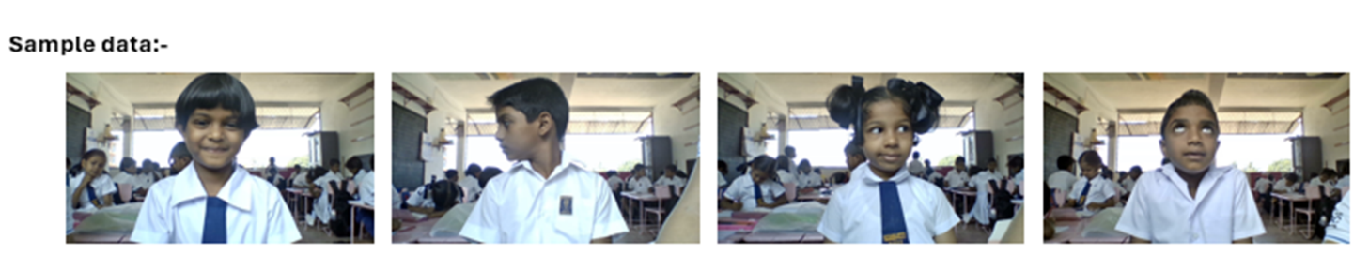

Figure 1:Sample data

### 2.1.3. System Architecture

Figure 2:Overall system diagram

The primary objective of this project is to develop an adaptive online learning platform for primary students, addressing the current limitations in the field. A unique facial authentication system will streamline the login process, eliminating the need for students to remember passwords, thereby making it more user-friendly for the target demographic. Additionally, a meticulously designed quiz will be employed to gauge the emotional state of the students, and in cases where guidance is deemed necessary, personalized advice will be provided to the teachers to support the students effectively. Furthermore, a sophisticated recommendation system has been developed to suggest study materials tailored to the individual student's performance on the quizzes. Lastly, a real-time attention monitoring system has been integrated to track students' attentiveness during the quizzes, providing teachers with valuable insights into their students' engagement levels.

### A diagram of a diagram of a computer Description automatically generated2.1.4 Component Architecture

Figure 3:Overall Component Diagram

The attention monitoring system utilizes a webcam to track the attentiveness of pupils in real-time during virtual exams. The MTCNN model continuously captures webcam images and detects facial expressions. The facial expressions that have been identified are retrieved, and the photos that have undergone preprocessing are inputted into a MobileNet model that has already been trained. This model provides predictions of the attention status and computes the attention score for each student once they complete and submit their answers at the conclusion of the assessment. The results dashboard presents the assessment outcomes, including metrics such as the highest and lowest durations of attention, offering valuable insights into the pupils' level of focus during the exam.

### 2.1.5 Tools and Libraries

* OpenCV: Open-Source Computer Vision Library (OpenCV) is instrumental in image preprocessing, face detection, and visualization.
* TensorFlow: Open -source library, used for training deep learning models.
* NumPy: Python package which supports multidimensional arrays and matrices.
* Pandas: The Pandas library facilitates the handling and manipulation of CSV data.
* Matplotlib: Matplotlib is adept at generating data visualizations.

### 2.1.6 Model Architecture and Model Implementation

MobileNet pre-trained model which is utilized based on MobileNet architecture to measure student attention levels during online quizzes. The MobileNet model is supplemented using transfer learning techniques, leveraging a pre-trained MobileNet model to boost the accuracy of attention estimation. In parallel, the MobileNet-based model predicts the images detected by face detection algorithm, which is MTCNN, continuously monitoring students' facial expressions throughout tests to provide immediate feedback on their concentration levels. The model efficiently uses the inherent capabilities of their distinct architectures to decode and interpret face dynamics, thereby providing precise attention measurement. In the early phase, great effort was dedicated to the pre-processing and refinement of the dataset, assuring robust performance of the model.

Step 1: Initially relevant libraries are imported.

Figure 4:Import Libraries for model implementation

Step 2: Load the dataset and Preprocessing.

Figure 5: Load the dataset and Preprocessing.

Step 3: Define and customize pretrained model.

Figure 6: Model defining image 1

Figure 7: Model defining image 2

Step 4: Build a new model that consists of the original MobileNet up to the fifth layer and reshape and add output layer.

Figure 8: Reshape and add output layer

Step 5: Freeze the weights of all other layer except output layer

Figure 9:: Freeze the weights.

 Step 6: Compile the Model

Figure 10:: Compile the model.

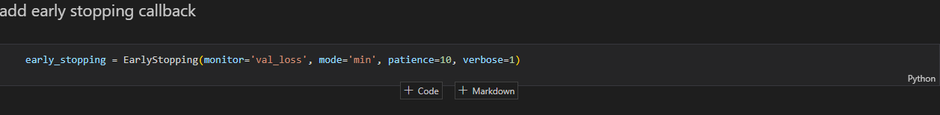 Step 7: Add early stopping callback.

Figure 11:Early stopping callback function.

Step 8: fit the model.

Figure 12:: Fit the model.

Step 9: When the model is training after a few steps the model has identified the training and validation accuracy is not enough therefore early stopping function is called and model stopped the training at 10th epoch.

Figure 13:Terminate the model training.

Step 10: Fine tune the model.

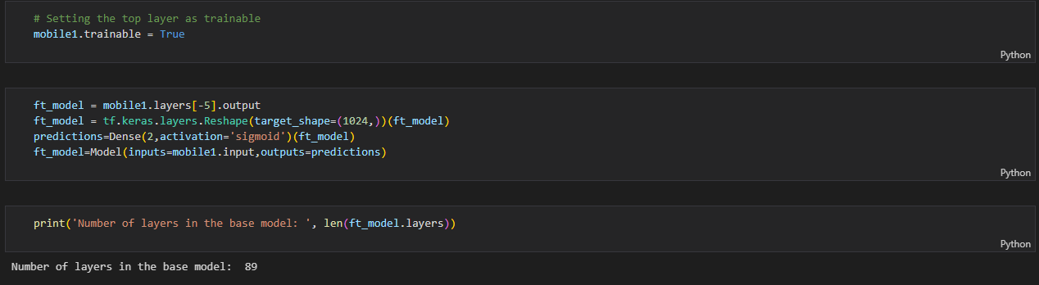

Figure 14: layers in base model

Step 11: After some trials and errors, I have identified that the model should be fine tune from the 60th layer onwards. Therefore, now the model is fine-tuned from this layer.

Figure 15: Start model fine-tuning.

Step 12: View model summary.

Figure 16: View model summary

Step 13: Continue model training.

Model is not training from the starch. It is starting the training process from the stopped epoch.

Figure 17: Training the fine-tuned model.

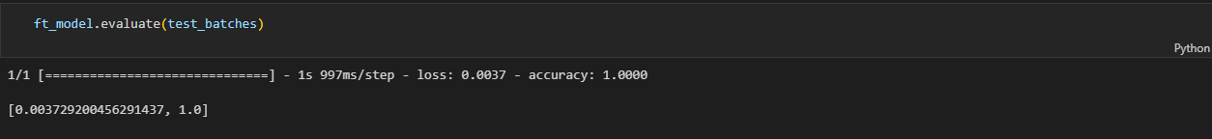 Step 15: Evaluate model for test batches.

Figure 18: Evaluate model for test batches.

Step 16: Loading test images.

Figure 19: loading test images 1

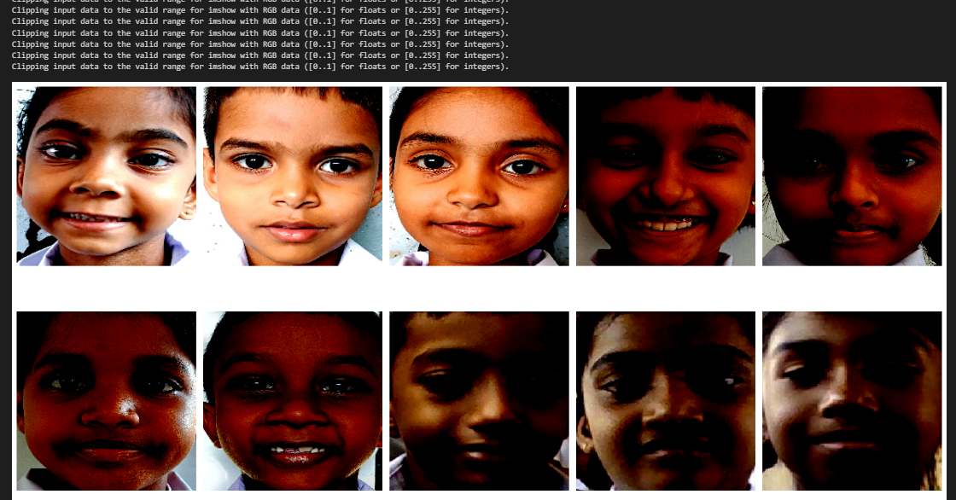

Figure 20: Loading test images 2

Step 17: Predict the class of test images.

Figure 21: Predict test images.

Step 18: Confusion matrix.

Figure 22: Confusion Matrix for model

### 2.1.7 Face Detection Using MTCNN

Step 1: Import necessary Libraries.

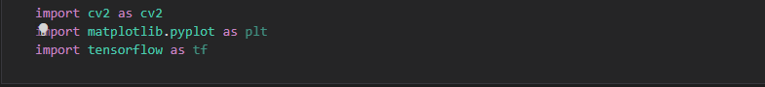

Figure 23: Import libraries for face detection model

Step 2: Load images.

Figure 24: load images

Step 3: Import MTCNN and define the function and input images to the function.

Figure 25: function define and input images.

Figure 26: facial key points of image

Step 4: Detecting face.

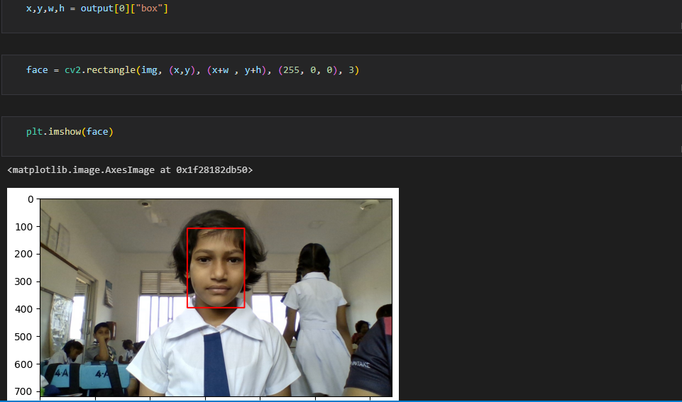

Figure 27: Detecting Face

### 2.1.8 Face Extraction

Step 1: Import libraries and MTCNN.

Figure 28: library import for face extraction.

Step 2: Define a function for face extraction.

Figure 29: Define function for face extraction.

Step 3: Extract and load images into folders.

Figure 30: Extract and load images.

## 2.2. Commercialization Aspects of the Product

### 2.2.1. Target Market

Our primary target market includes primary school students and their parents or guardians. We aim to address attention monitoring systems among children and provide tailored advice to improve their e – learning performance. Additionally, we will collaborate with schools and educational institutions to integrate our system into their curriculums, making it accessible to a wider audience of educators and students.

### 2.2.2. Revenue Streams

To generate revenue, we will implement a multi-tiered monetization strategy. This will include subscription-based models for individual users, schools, and educational institutions. We will also offer premium features and personalized advice packages as upsells. Furthermore, we will explore partnerships with educational platforms and content providers to offer value-added services.

### 2.2.3. Marketing Approach

**Phase 1: Product Development and Testing**

Launch the initial version of the system in collaboration with pilot schools to gather feedback and refine the product based on real-world usage.

**Phase 2: Freemium Model and Educational Partnerships**

Introduce a freemium model offering basic emotional assessment and generic advice, with premium features and personalized advice available through subscription. Forge partnerships with educational institutions to promote the system as part of their online learning programs.

**Phase 3: Digital Marketing and Awareness Campaigns**

Utilize digital marketing channels such as social media, educational forums, and targeted online ads to raise awareness about our system. Engage in campaigns focused on highlighting the benefits of attention monitoring in education.

**Phase 4: Community Building and Advocacy**

Build a community of parents, educators, and mental health professionals who advocate for the importance of attention monitoring in online learning. Organize workshops, webinars, and events to promote discussions and knowledge sharing on enhancing e-learning performance via attention monitoring.

**Phase 5: Strategic Partnerships and Expansion**

Form strategic alliances with educational technology companies, child psychologists, and mental health organizations to expand our reach and enhance the effectiveness of our system. Explore international markets and localization opportunities to cater to diverse cultural contexts and languages.

## 2.3 Testing and Implementation

### 2.3.1. Functional Requirements

**Analyze facial features in real-time with a camera or image feed:**

* The program should be able to collect, process and analyze facial features in real-time.

**Classify user attention status, attention levels and predict attention score in real-time:**

* The system should be able to predict,

attention levels as ‘Excellent’, ‘Good’, ‘Average’ and ‘Need to improve.’

attention status as ‘attention paying’ or ‘attention not paying.’

attention score.

**Real -time feedback is provided regarding the attention status:**

* While student is doing the online assessments/ quiz, if student lost attention system will display as ‘pay attention’ if the student is paying attention, it will display as ‘all good’
* If a student continuously not paying attention to the assessment for around 30 seconds of duration the quiz will stop, and pop-up message is displayed with the user-friendly sound (Child voice) and say pay attention to the quiz. When students look back to screen the pop-up message will disappear and student is directed to the quiz.

**Student performance analysis using results dashboard:**

* Results dashboard displays exam results, attention level, attention score, maximum attention span, minimum attention span.

**Improve the model accuracy and implemented an efficient model using small amount of dataset using transfer learning.**

### 2.3.2. Non-Functional Requirements

**Performance:**

* The system should be responsive and provide real-time feedback to students and teachers.
* The system should be optimized for efficient resource utilization and minimum computational overhead and ensuring high performance.

.

**Scalability:**

* The system should be able to handle an increasing number of users and data without compromising performance.

**Privacy and Security:**

* The system should implement proper authentication and authorization mechanisms to protect sensitive data.
* The system should ensure privacy and confidentiality of students’ data, including facial images and attention data.
* Student information regarding quiz results and the attentiveness, should be encrypted and securely stored.

**Usability:**

* The user interface should be intuitive and easy to navigate, especially for primary school students.
* The system should provide clear instructions and guidance for students and teachers.
* Since the users are primary school students, the system should be user-friendly and easy to use.

**Extensibility and Maintainability:**

* The system should be designed in a modular and extensible manner, allowing for the addition of new features or integration with other systems in the future.
* The system's codebase should be well-documented and follow the best coding practices to facilitate future maintenance and updates.

**Robustness:**

* The system should handle unexpected inputs and edge cases gracefully, without crashing or compromising data integrity.
* Necessary error handling and recovery mechanisms should be implemented with the system to ensure reliability of the system.

### 2.3.3 Backend Implementation

The model was trained, and a dump file of the pre-trained model was first deployed to the flask server. The steps that were taken to implement the backend and frontend of this component are well described in the following.

Step 1: Import libraries and load the model.

Figure 31 Import libraries for backend

Step 2: Define function to predict class of the image.

Figure 32:Define function for class prediction.

Step 4: Real -time image frames capture and extract the face of the image and assign the predicted class for the image. And the imaged and the prediction of the image is passed to the fronted.

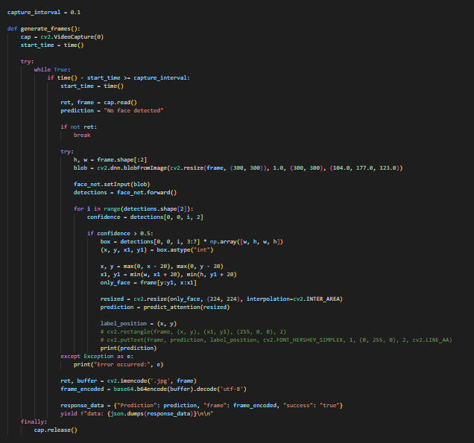

Figure 33: Real – time predictions taking.

### 2.3.4. Frontend and Backend Testing

The system is tested with the users and here is the evidence to prove that. In the system students are given virtual assessment training. While the students engaging with the quiz real -time attention status is predicting, and it is displayed on the screen.

1. Home page of the quiz to navigate the virtual assessment training.

Figure 34: Home page

1. A screenshot of a computer

   Description automatically generatedWhile student engage with the quiz and when the student paying attention to the quiz system will display the attention status of the student as all good.

Figure 35: Student attention giving.

1. While student engage with the quiz and when the student is not paying attention to the quiz system will display as ‘Pay attention’ to the quiz.

Figure 36: Student attention not giving.

1. A screenshot of a computer

   Description automatically generatedWhen student continuously do not pay attention for 30 seconds without paying attention, the system will display the real – time feedback as a pop-up message with the user-friendly child sound calling the students get back to the quiz.

Figure 37:Pop-up message

1. A screenshot of a computer

   Description automatically generatedAfter the student is done the quiz and answers are submitted. The results of the quiz will display in a results pop-up with the attention status, attention score results, Minimum continuous attention span and maximum continuous attention span results.

Figure 38: Results of the quiz

1. A screenshot of a computer

   Description automatically generatedStudents and the teachers and view the results dashboard for further analysis.

Figure 39: Results dashboard

# 3. RESULTS AND DISCUSSIONS

## 3.1 Results.

In this section, we analyze the results and findings obtained from our experiments with the MobileNet pre-trained model with use of transfer learning and for the face detection MTCNN model, for attention monitoring in real time.

**Model Test results.**

Before fine – tuning the model.

Figure 40: Before fine - tuning the model.

Model accuracy.

Figure 41: Before fine - tuning the model accuracy.

After fine-tuning the model.

Figure 42: After fine-tuning the model matrix

Model Accuracy

Figure 43: Model after fine-tuning accuracy.

Confusion matrix

Figure 44: Confusion matrix for the model

## 3.2 Research Findings.

Results from the first application of the pre-trained MobileNet model for attention monitoring were obtained with a validation accuracy of 0.6500 and a training accuracy of 0.7044. The test accuracy was, nevertheless, noticeably lower at 0.6000, suggesting possible overfitting and the necessity for additional optimization. We used attention labels and carefully selected dataset of children's facial expressions to use fine-tuning methods on the pre-trained MobileNet model to solve this problem. Performance was much improved by this method; the validation accuracy was 0.9667 and the training accuracy was an astounding 0.9969. The performance of the model following fine-tuning was insightfully shown by the confusion matrix and assessment measures. With micro-averaged precision, recall, and F1-scores of about 0.9835, the performance was excellent overall at all attention levels. Well-distributed performance shown by the macro-averaged metrics—a macro-averaged F1-score of about 0.9812—suggests constant efficacy in precisely categorizing different levels of attentiveness. Using webcam feeds, we conducted real-time attention monitoring to further verify the practical applicability of our refined model. Through simulated online tests, the model was shown to be able to precisely monitor and evaluate student attention levels. Because of the real-time feedback and attention scores, teachers were able to quickly spot and correct changes in student involvement.   
The major influence of transfer learning methods and fine-tuning was revealed by a comparison analysis between the original pre-trained model and the refined version. Although the pre-trained model performed well, the refined model showed better accuracy and consistency at all attention levels. This emphasizes how our method may be used in adaptive learning settings and online evaluations. We investigated how to include background noise levels and lighting situations as contextual cues into the attention monitoring system. The results imply that including these elements improves the model's performance even more since they offer insightful information about the surroundings that could affect students' attention during online tests. Our attention monitoring system, which uses deep learning and transfer learning, is shown to be effective by the research results. Real-time monitoring features and precise attention assessment of the system open the door to improving online learning and enabling customized teaching plans for primary school students.

## 3.3 Discussion

The outcomes from the attention monitoring system provide important new information on how well deep learning methods and transfer learning strategies measure student attention during online tests. This discussion part seeks to clarify the wider importance of this study and go further into the ramifications of these results.   
  
3.3.1 Model Performance and Analysis of Comparisons

At 0.6500 for validation accuracy, the pre-trained MobileNet model's first implementation showed promise. But a significant increase resulted from the fine-tuning procedure, which used the carefully selected dataset of kids' facial expressions and attention labels; the validation accuracy reached an astounding 0.9667. The transfer learning approach is responsible for this notable improvement since it enables the model to successfully capture the particular traits and subtleties of kids' facial expressions and actions during online tests. The great influence of transfer learning methods and fine-tuning was revealed by comparing the original pre-trained model with the refined version. Although the pre-trained model performed well, the refined model showed better accuracy and consistency at all attention levels. This emphasises how our method may be used in adaptive learning settings and online evaluations.   
  
3.3.2 Relevance to Practice and Uses

Webcam feeds were used in a real-time attention monitoring demonstration to highlight how well the system tracked and evaluated student attention levels during simulated online exams. This capacity has important ramifications for improving online learning and enabling customised teaching approaches in primary school classrooms. Giving teachers instant feedback and attention scores, the technology enables them to quickly spot and fix changes in student involvement. Because of this real-time monitoring feature, teachers can adjust the assessment format, modify their teaching strategies, or offer individualized support to keep students focused during the online assessment process. The model's results indicate that adding these contextual elements can improve its accuracy even more because they offer insightful information about the variables that could affect students' attention during online tests. This attention monitoring system has more useful uses than only online tests. Through integration into a variety of online learning platforms and virtual classroom settings, the system allows teachers to continuously track and evaluate student participation levels during lectures, discussions, or group projects. For primary school pupils, this real-time feedback might support individualized interventions, adaptive learning tactics, and eventually more successful and interesting online learning experiences.

### 3.3.3 Limitations and Future Directions

**Scalability and Outside Validation:**   
  
Performance of the attention monitoring system should be further assessed in various educational contexts or on external datasets. This would give a more thorough knowledge of its applicability and efficacy in various learning contexts and demographics. Working along with more elementary schools and educational institutions would make it easier to do extensive external evaluation, which would guarantee the system's reliability and usefulness in practical situations.  
  
  
**Model Refinement and Adaptation on a Continuous Basis**   
  
Refinement and adaptation of the attention monitoring system are essential as online learning environments and evaluation techniques change. This might need adjusting the deep learning models with new datasets and introducing novel methods for managing changes in background noise, illumination, or other environmental variables that could affect how attentive students are. Keeping the system current with the most recent developments in computer vision and deep learning will guarantee its efficacy and relevance for a very long time. Personalized educational technologies and adaptive learning platforms can be integrated with the attention monitoring system to unleash its full potential. These platforms might dynamically modify the content, tempo, and delivery techniques of online tests and learning materials to suit the demands and levels of engagement of each student by using real-time attention data and analytics. Maximizing educational results, this integration would make online learning genuinely individualized and interesting.   
  
**Privacy and Ethical Aspects**   
  
The attention monitoring system must handle privacy and ethical issues because it handles sensitive data including facial photos and attention levels. Top priorities should be to put strong data protection measures in place, get participants' informed permission, and follow pertinent privacy laws and rules. Moreover, guaranteeing responsibility and openness in the decision-making procedures of the system will promote acceptance and trust among teachers, students, and educational institutions.

# 4. CONCLUSION

The primary purpose of this research project was to design a robust and accurate attention monitoring system suited exclusively for online quizzes and assessments in elementary education settings. Through the combination of deep learning techniques, transfer learning methodologies, and a complete strategy that incorporates physical, emotional, and contextual clues, we have accomplished a substantial advancement in the field of artificial intelligence in education. Our research has shown the dramatic benefit of using pre-trained models, such as MobileNet, and fine-tuning them with a curated dataset of children's facial expressions and attention labels. By applying transfer learning approaches, we have efficiently recorded the distinctive qualities and nuances of students' facial expressions and actions throughout online examinations, resulting in excellent accuracy and consistency in attention level classification.

The implementation of real-time attention monitoring tools has been a major achievement, enabling continuous tracking of students' involvement levels throughout online tests. This real-time input helps instructors to swiftly recognize and resolve changes in attention, permitting immediate interventions and individualized instructional tactics. By giving insights into individual students' attention habits, our system lays the path for tailored and adaptive learning experiences, ultimately increasing educational outcomes for elementary school kids. our holistic approach, which integrates physical clues, emotional cues, and contextual elements, has proven useful in overcoming the limits of systems that merely rely on physical cues. By identifying the intricate interplay of elements that influence student attentiveness during online exams, our approach delivers a holistic knowledge and accurate measurement of engagement levels. While our research has reached significant milestones, we realize the need of continuing development and addressing potential constraints. Future initiatives should focus on increasing the dataset to include a broader variety of individuals, providing thorough coverage across all ethnicities, cultures, and socioeconomic backgrounds. Continuous model improvement and modification will be vital as online learning environments and evaluation methodologies evolve, assuring the system's long-term relevance and efficacy.   
The integration of our attention monitoring system with adaptive learning platforms and personalized educational technologies holds great promise for revolutionizing the online learning landscape. By dynamically altering content, pace, and delivery methods based on real-time attention data and analytics, these platforms may provide highly individualized and engaging learning experiences, maximizing educational outcomes for each individual student.

As we negotiate the ethical landscape surrounding sensitive data processing and privacy concerns, it is vital to prioritize robust data protection mechanisms, get informed consent, and comply with relevant privacy rules and guidelines. Transparency and accountability in the system's decision-making procedures will create confidence and acceptance among educators, students, and educational institutions, opening the path for wider adoption and good societal impact. Our research has created a solid foundation for the integration of artificial intelligence and deep learning techniques in online education, notably in the field of attention monitoring and adaptive learning. By harnessing the power of these technologies, we can alter the way we approach online exams and virtual classroom environments, ultimately promoting more engaging, individualized, and effective educational experiences for students globally.

# 5. REFERENCES

|  |  |
| --- | --- |
| [1] | M. L. a. M. D. a. J. J. D. Roy, "Students attention monitoring and alert system for online classes using face landmarks," in *2021 IEEE 4th International Conference on Computing, Power and Communication Technologies (GUCON)*, 2021, pp. 1--6. |
| [2] | X. a. Y. J. a. L. J. a. Z. H. a. S. H. Ling, "A deep-learning based method for analysis of students’ attention in offline class," *Electronics,* vol. 11, p. 2663, 2022. |
| [3] | R. a. S. S. a. V. P. a. S. K. Rahul, "Real-time attention span tracking in online education," in *2020 IEEE MIT Undergraduate Research Technology Conference (URTC)*, 2020, pp. 1--4. |
| [4] | S. A. a. P. M. a. M. P. a. K. M. R. a. B. K. Narayanan, "Attention analysis in e-learning environment using a simple web camera," in *2012 IEEE International Conference on Technology Enhanced Education (ICTEE)*, 2012. |
| [5] | Z. a. A. F. a. P. M. M. A. a. G. M. a. A. L. Trabelsi, "Real-time attention monitoring system for classroom: A deep learning approach for student’s behavior recognition," *Big Data and Cognitive Computing,* vol. 7, p. 48, 2023. |
| [6] | J. H. a. D. R. a. T. S. D. a. J. H. a. N. N. a. M. A. a. N. S. Dewan, "Image Classification by Transfer Learning using Pre-Trained CNN Models," in *2023 International Conference on Recent Advances in Electrical, Electronics, Ubiquitous Communication, and Computational Intelligence (RAEEUCCI)*, 2023, pp. 1--6. |